This article provides a detailed explanation of how to connect the Redpark adapter to Ethernet. Also, it contains a detailed FAQ to help provide clarity to customers should they have questions about the necessity of using the Repark solution.

**Contents**

RedPark Lightning PoE Instructions

RedPark FAQ

What is the RedPark Solution?

What does it Replace?

What’s Included?

Why is this needed?

Alternative Solutions to RedPark

### 

## RedPark Lightning PoE Instructions

Note: Do not plug into power until the final step.

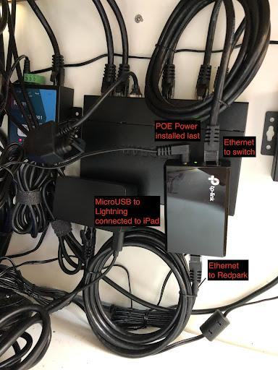

* The PoE Injector will automatically determine how much power to deliver and if this is done out of order the solution may not send enough power for all connections
  + Locate the PoE Injector.
  + Remove from the box and remove any plastic wrapping:

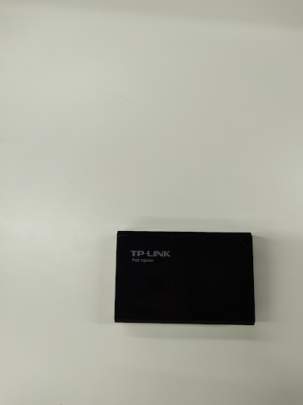

* Attach an Ethernet Cable to the “LAN in” port
  + Note: do not use the included tan cable in the box.

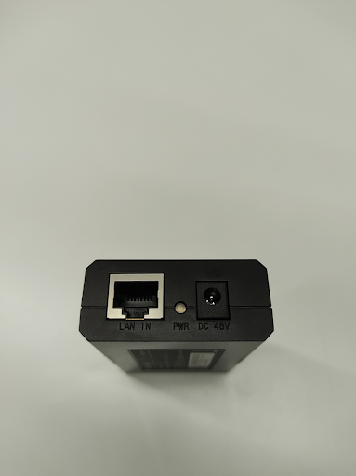

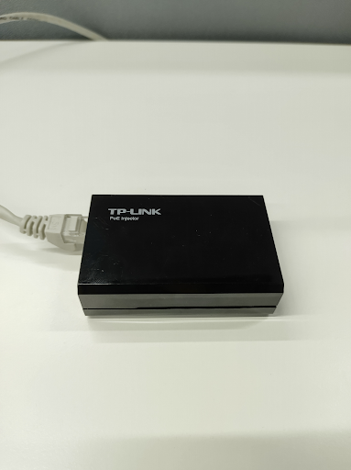

* Use the provided black cables provided by Revel.
* Connect the loose end of the Ethernet cable into the switch or dedicated wall port.
* Attach an Ethernet cable to the “Power Data Out” port of the PoE Injector:

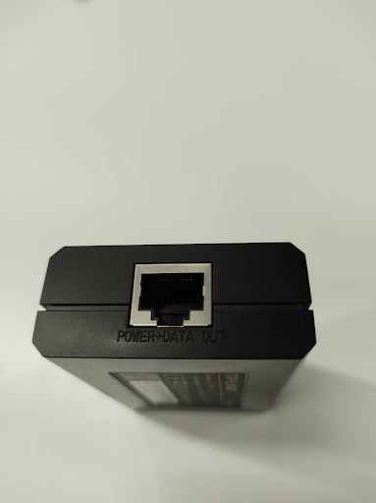

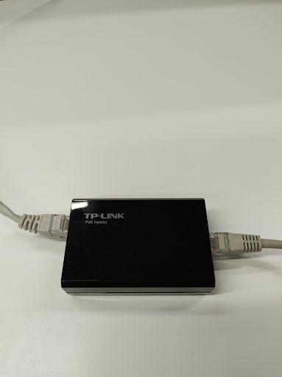

* Connect the loose end of the cable to the RedPark Adapter:

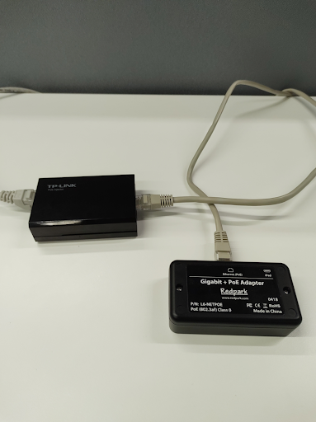

* Connect the Power Adapter to the injector but DO NOT PLUG INTO POWER OUTLET:

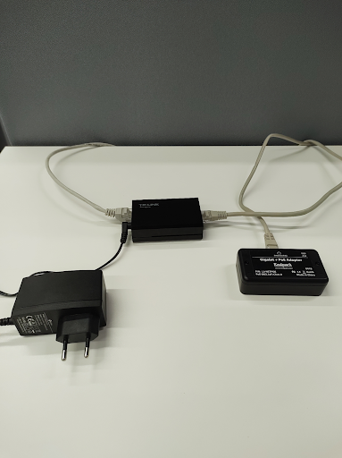

* On the RedPark adapter, attach the provided Micro USB to Lightning Cable and plug it into the iPad.
* Once all of the above steps are done, plug the PoE Injector into the power outlet:

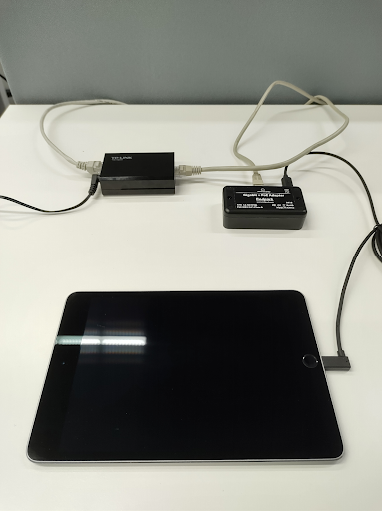

* iPad should power on after a few seconds.

**Once iPad is powered on:**

* Disable Single App Mode (Revel Install Support Team)
* Open iPad Settings App
* Locate Ethernet
* Tap into the Ethernet connection
* Disable “Limit IP Address Tracking”
* Change Configure IP from Automatic to Manual
* Apply the appropriate IP address, subnet mask, and router information
* Save by tapping the blue arrow and text on the top left middle of that page
* Tap “Configure DNS”
* Select “Manual”
* Tap “Add Server”
* Add [removed]
* Tap “Add Server”
* Add [removed]
* Save by tapping the blue arrow and text on the top left middle of that page
* Ensure WiFi is OFF
* Minimize the Settings App
* On the iPad, drag down from the top right corner (might have to do it two times) and reduce screen brightness to 75%
* Enable Single App Mode (Revel Install Support Team)

Perform the remainder of the installation in accordance with the Revel Station Installation & Provision Steps

REPEAT ALL STEPS ABOVE FOR THE REMAINING STATIONS  
WHEN ALL STATIONS ARE DONE PERFORM A REFRESH OF ALL STATIONS  
  
NOTE: RedPark has identified a potential issue their RedPark Lightning Adapter may encounter with iOS 16.4.1. If your ethernet is not showing up in settings, please use the following troubleshooting steps:

* Check iOS version - if 16.4.1
  + Disconnect from the cable and reboot
  + Reconnect cable and check if ethernet shows up in settings

## RedPark FAQ

### What is the RedPark Solution?

The RedPark Gigabit + PoE Adapter for iPad (L6-NETPOE) is an adapter, made specifically for iPads equipped with a lightning port, that provides power and data to an iPad via Power over Ethernet (PoE)

### What does it Replace?

The RedPark adapter replaces the traditional Apple Ethernet Connect adapter set specifically for iPads equipped with a lightning port. This replaces the following components:

* Apple USB 3 Camera Adapter
* Belkin USB A Ethernet Adapter
* iPad Lightning Cable (provided in the box with iPad)
* iPad 20W USB C to Lightning Charge/Sync Cable (Provided in the box with iPad)

### What’s Included?

The RedPark Bundle Consists of:

1 - RedPark Adapter  
1 - RedPark Micro USB to Lightning Cable, 90° angle cable  
2 - 5 ft CAT6 Ethernet Patch Cables

### Why is this needed?

Some Apple Ethernet Connect setups are experiencing a charging issue, in which the iPad will, sometimes, lose charge despite being plugged in or cease charging completely. The solution at the moment is to unplug and replug the adapters. If that does not work, then plug the iPad directly into power and get to 100% before plugging in the adapter set. This is not ideal and if not caught in time, it can lead to an iPad draining completely, which can have a detrimental effect on the business.

Lightning iPad Models that have been confirmed affected by this charging issue:

* 7th gen iPad
* 8th gen iPad
* 9th gen iPad

As of now, testing has not shown 6th gen or older models to be affected; however, it is not outside the realm of reason that this could happen to them.

iOS Versions that this has happened to are iOS 15.2 and newer versions, including iOS 16.4.1

Revel Product Management has decided to move away from the Apple Ethernet Connect setup as a whole and move forward with RedPark as our preferred ethernet solution for the following reasons:

* Stability in charging
* Stability in networking
* Fewer moving parts above the counter
* Ease of installation
* Ease of troubleshooting

### Alternative Solutions to RedPark

Should a merchant decide that they do not wish to move to RedPark the options are as follows:

* Switch to Wifi
  + Follow standard procedure to move a merchant setup from ethernet to wifi.
    - Verify MAC fields and IP fields are updated on the relevant stations.
* Continue to use the AEC
  + Attempt to correct charging by unplugging and replugging in the adapter set.
  + Plug the iPad directly into power and charge to 100% before plugging in the AEC adapter set again.

If they choose to continue with AEC, then the above steps are the only options at this time.